**Week 1 : Introduction To Machine Learning**

Overview of Machine Learning

Welcome to machine learning!

Applications of machine learning

Supervised vs. Unsupervised Machine Learning

What is machine learning?

Supervised learning part 1

Supervised learning part 2

Unsupervised learning part 1

Unsupervised learning part 2

Jupyter Notebooks

Lab: Python and Jupyter Notebooks

Regression Model

Linear regression model part 1

Linear regression model part 2

Lab: Optional lab: Model representation

Cost function formula

Cost function intuition

Visualizing the cost function

Visualization examples

Lab: Optional lab: Cost function

Train the model with gradient descent

Gradient descent

Implementing gradient descent

Gradient descent intuition

Learning rate

Gradient descent for linear regression

Running gradient descent

Lab: Optional lab: Gradient descent

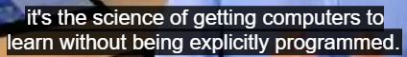

machine learning is the science of getting computers to learn without being explicitly programmed.

### Learning Objectives

* Define machine learning
* Define supervised learning
* Define unsupervised learning
* Write and run Python code in Jupyter Notebooks
* Define a regression model
* Implement and visualize a cost function
* Implement gradient descent
* Optimize a regression model using gradient descent

supervised learning :

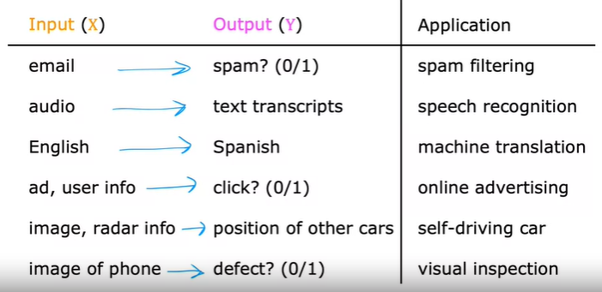

supervised learning :part 1- Regression

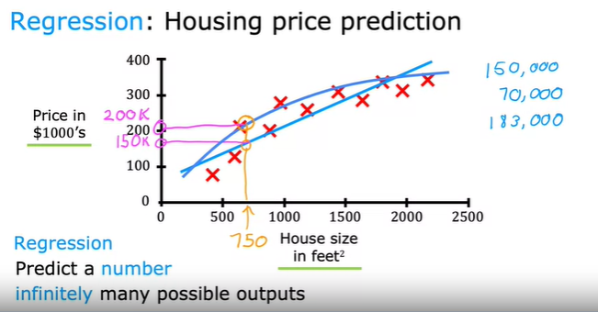

supervised learning :part 2- Classification

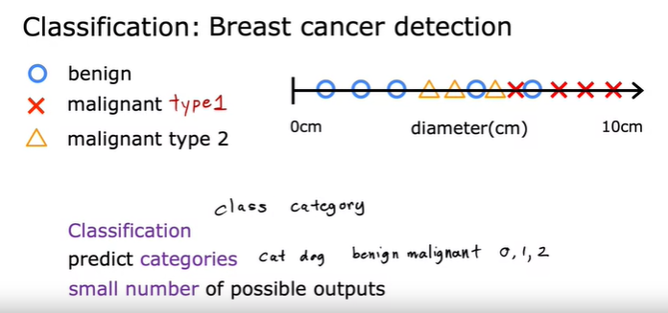

Unsupervised learning :part 1-

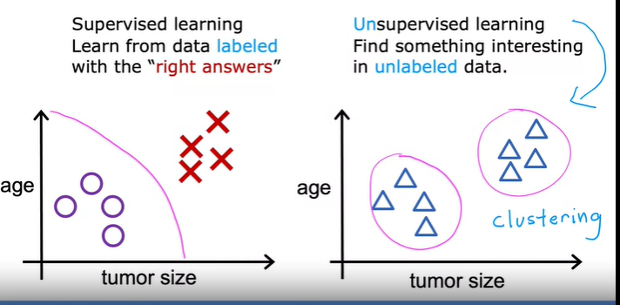

Unsupervised learning : Clustering - Eg. 1 - Google News

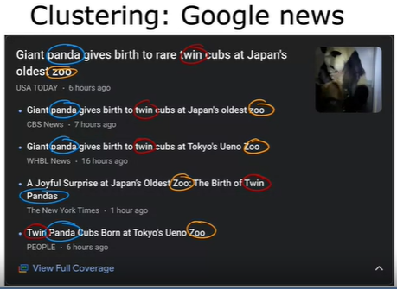

the algorithm has to figure out on his own without supervision, what are the clusters of news articles today. So that's why this clustering algorithm, is a type of unsupervised learning algorithm.

I don't know what the different types of people are but can you automatically find structure into data. And automatically figure out what are the major types of individuals, since we're not given the algorithm the right answer for the examples in advance. This is unsupervised learning

Unsupervised learning : Clustering - Eg. 2 - DNA microarray

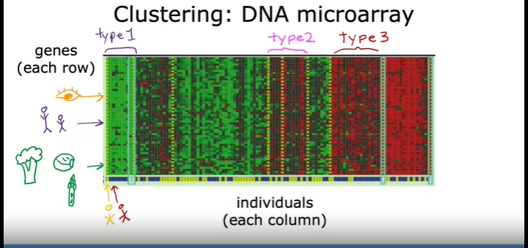

Unsupervised learning : Clustering - Eg. 3 - Grouping Customers

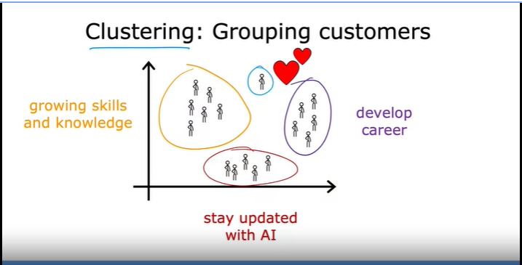

Unsupervised learning :part 2-

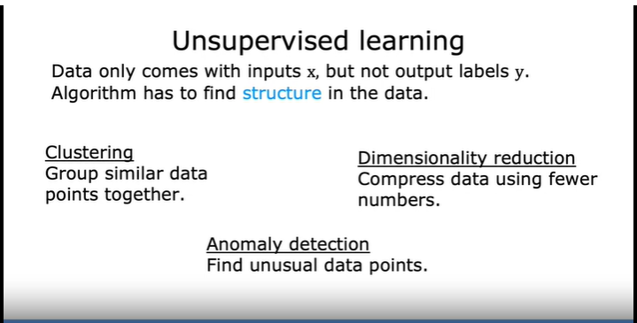

Linear regression model : part 1

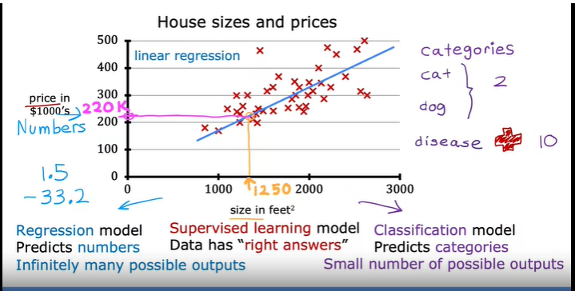

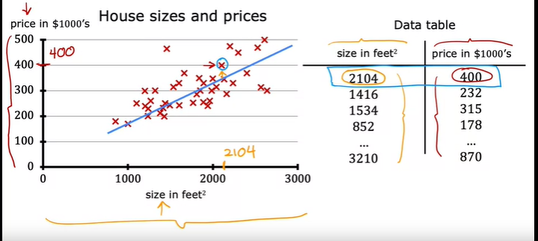

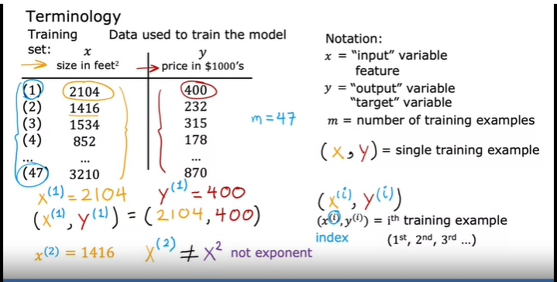

Linear regression model : part 2

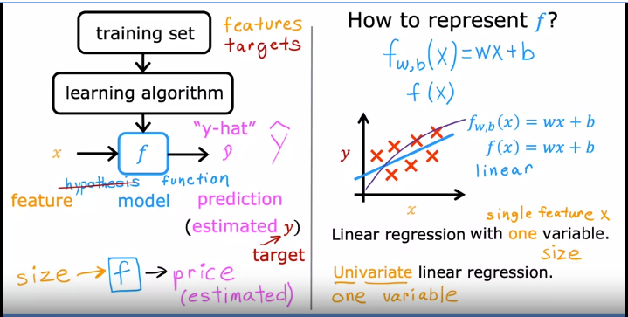

Cost function formula :

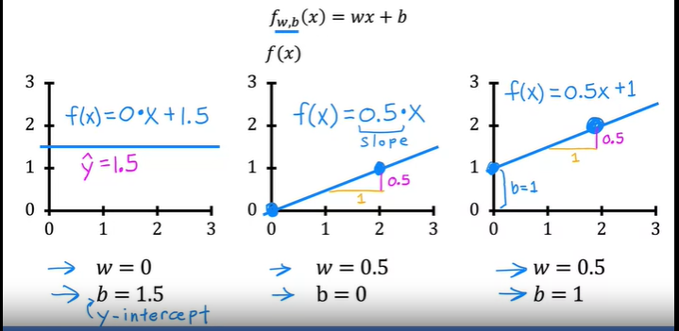

# Cost function formula :

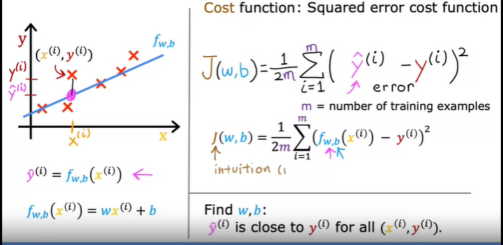

# Cost function intuition :

W = 1

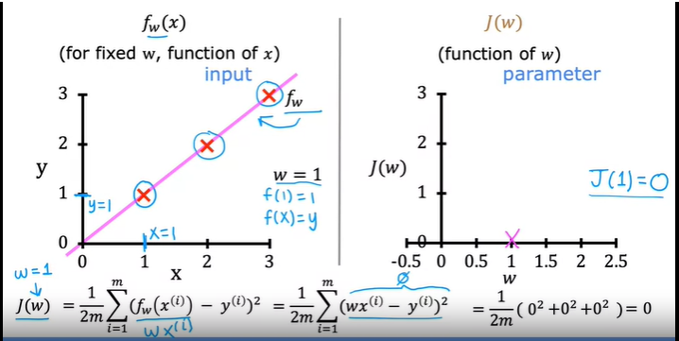

W = 0.5

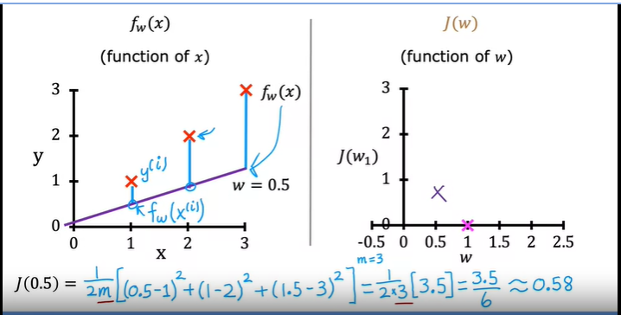

W = 0, -0.5, …

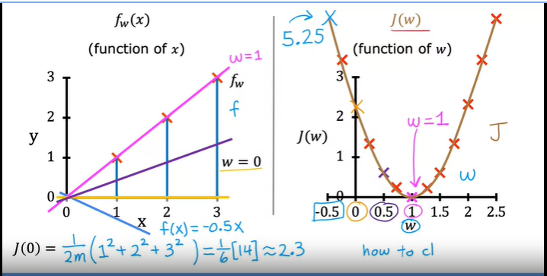

# Goal of linear regression : To minimize the cost function

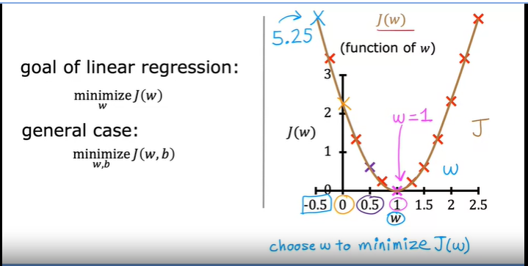

# Visualizing the cost function :

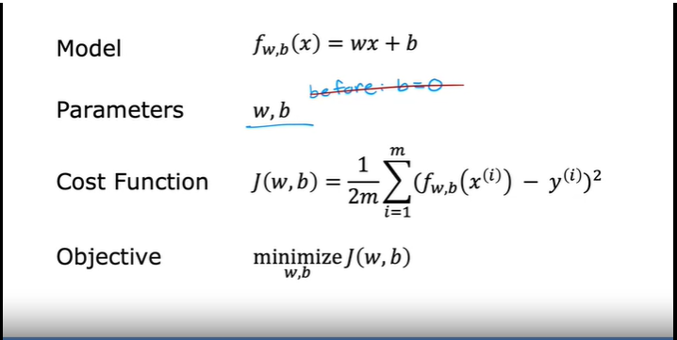

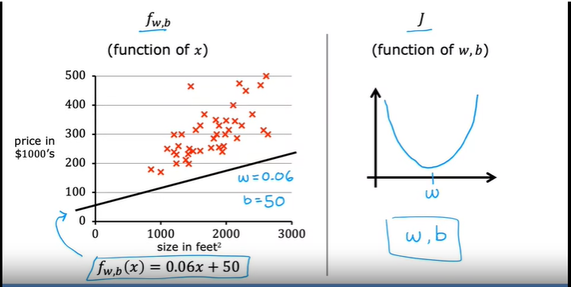

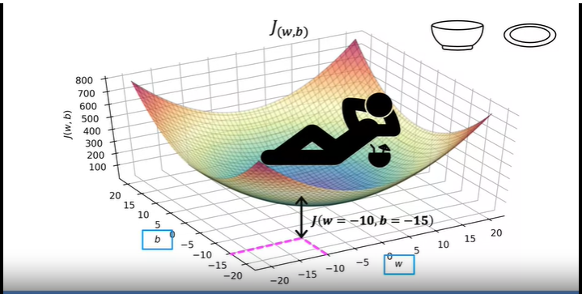

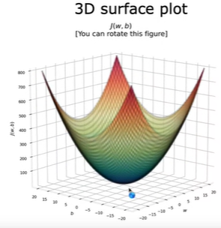

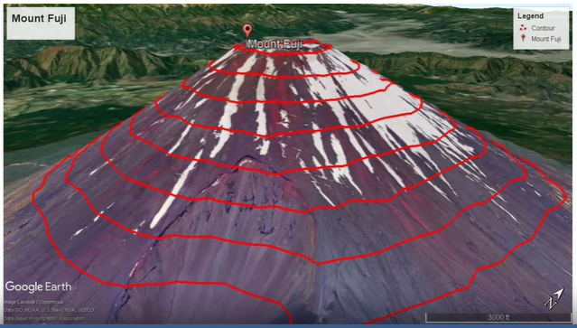

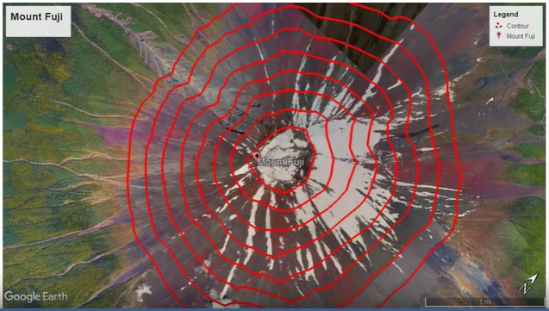

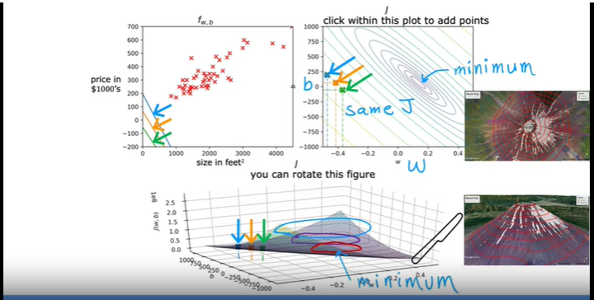

# Visualization examples :

# Bad fit

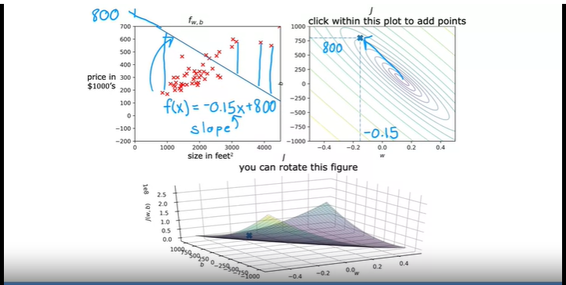

# Not That bad fit

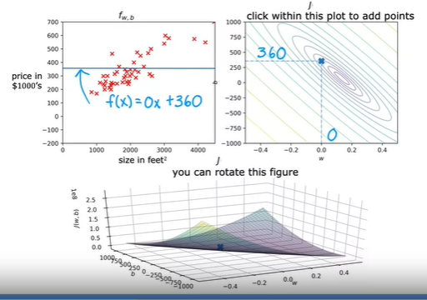

# Not The Great fit

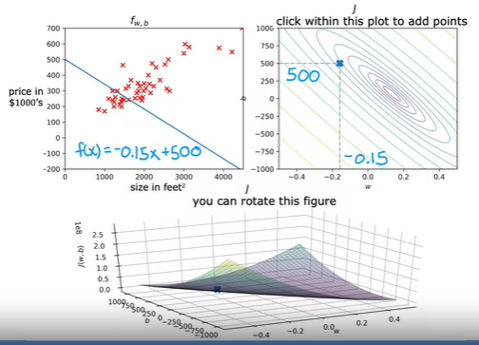

# Pretty Good fit

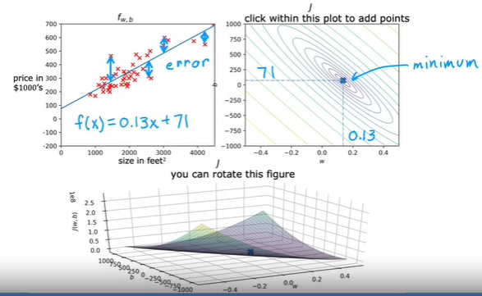

# Gradient descent :

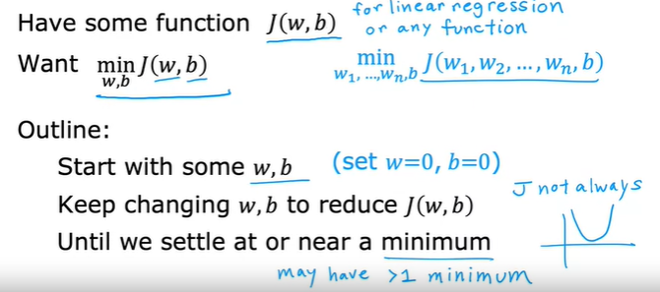

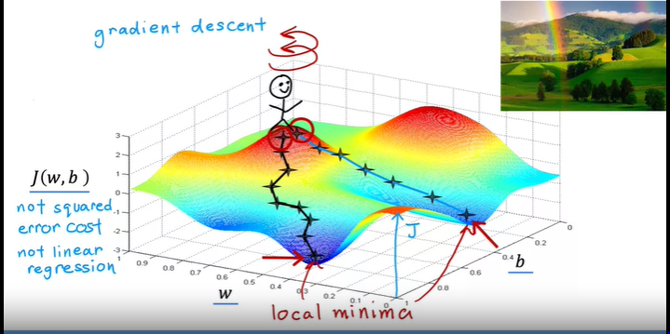αα

# Implementing gradient descent :

α = Learning rate, 0 to 1, (say 0.01) = size of the baby step

Partial derivative = 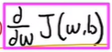 = Direction for the baby step

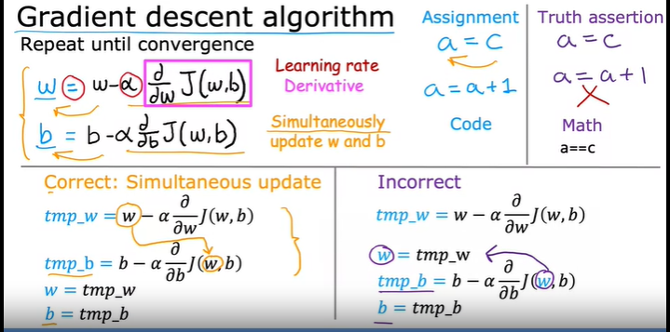

# Gradient descent intuition :

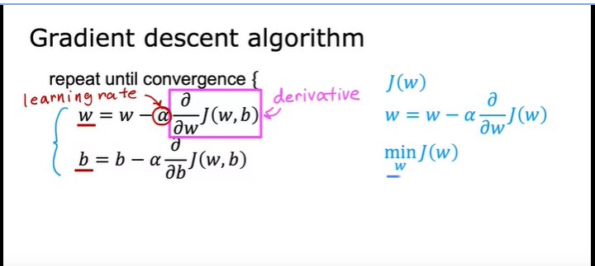

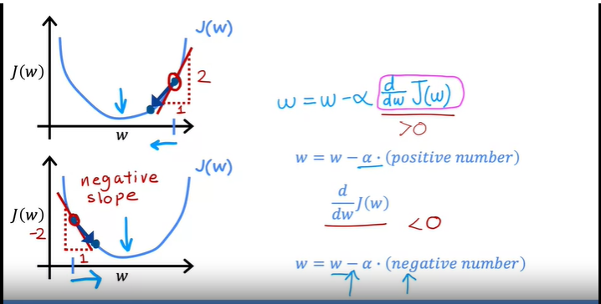

# Learning rate :

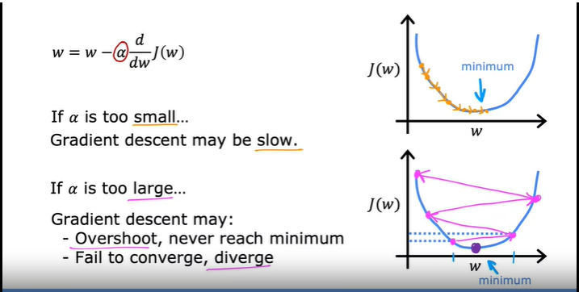

Learning rate : Tricky situation of 2 local minimas

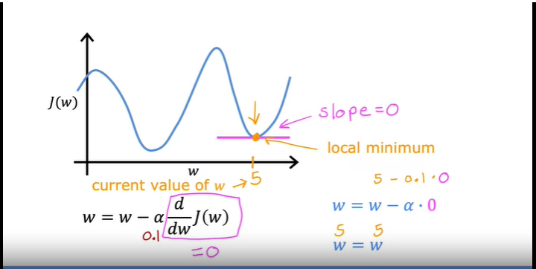

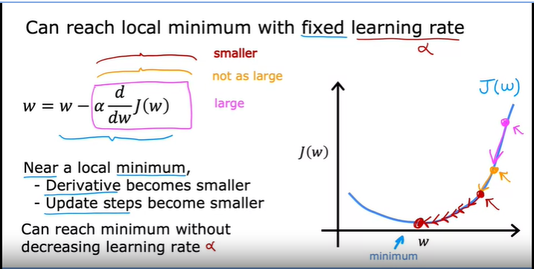

# Gradient descent for linear regression :

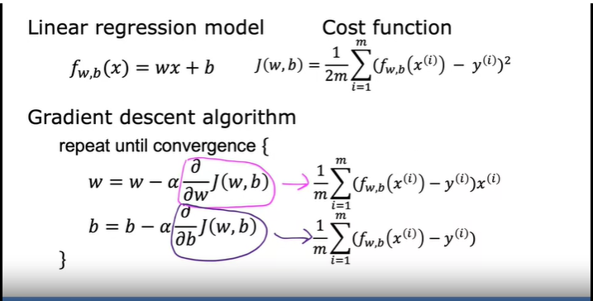

# Gradient descent for linear regression : with calculus (partial differentiation) steps

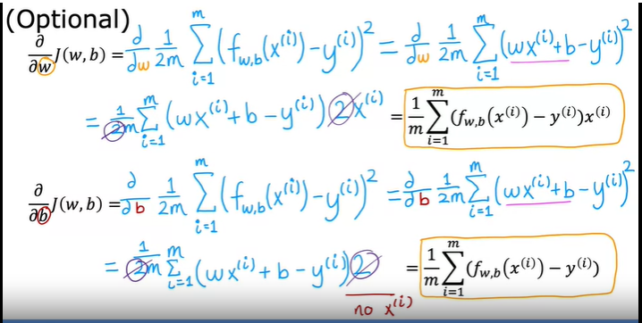

Gradient descent for linear regression : Final compilation

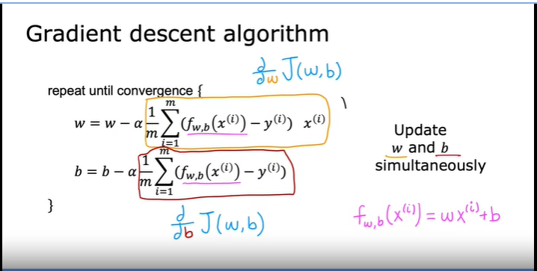

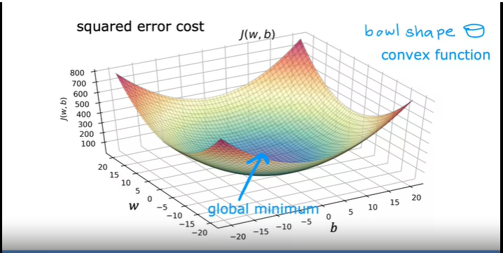

# Running gradient descent :

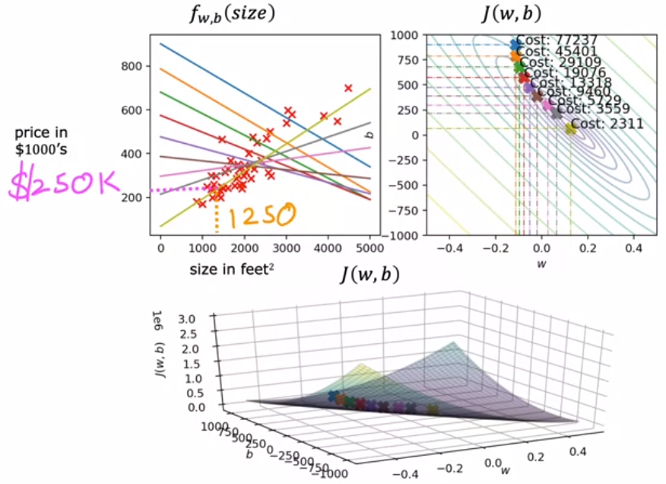

Batch gradient descent :

